# Design Documentation

# Free choice

Revision History

|  |  |  |  |
| --- | --- | --- | --- |
| **Date** | **Version** | **Description** | **Author** |
| 22/09/21 | 1.0 | Initial discussion of design | Fanny Söderlund, Malek Alabed, Nishat Jahan, Suzanne Zomer |
| 06/10/21 | 1.1 | Design of mock lab | Fanny Söderlund, Malek Alabed, Nishat Jahan, Suzanne Zomer |
|  |  |  |  |
|  |  |  |  |

Design item List

|  |  |  |
| --- | --- | --- |
| **Design name** | **Requirements related** | **Priority** |
| D1. Client android app environment | R1, R2, R3 | Essential |
| D2. Client web app environment | R1, R2, R3 | Essential |
| D3. Server/API connection | R2, R4, R5, R6, R8 | Essential |

Design Item Descriptions

**D1.**

A collection of the designs for the requirements relating to the android client side of the system.

***Mocked environment***

The mocked environment allows the features to be developed incapsulated without outside interaction. The mocked client app is a simple android app that contains the nessecary components for the related requirements. The mocked environmetn is created using Andorid Studio using Java to integrate with the other subgroups.

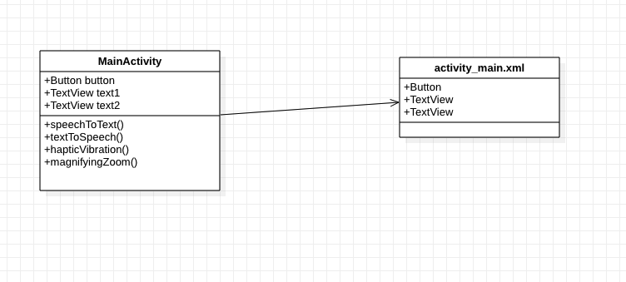

Figure - Class diagram of mock client android app

***Haptic vibration (R1)***

**D2.**

A collection of the designs for the requirements relating to the web client side of the system.

***Mocked environment***

The mocked environment allows the features to be developed incapsulated without outside interaction. The mocked client app is a simple web app that contains the nessecary components for the related requirements.

**D3.**

A collection of the designs for the requirements relating to the server of the system. Initially, for testing and developing, the mocked environment will be used, but eventuelly the implementations will migrate to the actual server/API.

***Mocked environment***

The mocked environment allows the features to be developed incapsulated without outside interaction. The mocked server allows for testing and implementing of features not yet handled by the current system.



Figure - General layout of mocked sever/client interaction